TO PURCHASE COLD WAR MEDAL SET

Basic Medal Set  Full size medal and ribbon bar  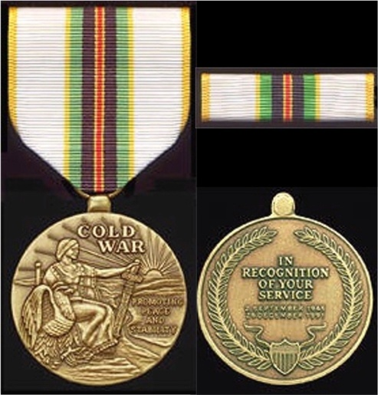  $24.95 | Full Medal Set  Full size medal and ribbon bar, miniature, and lapel pin  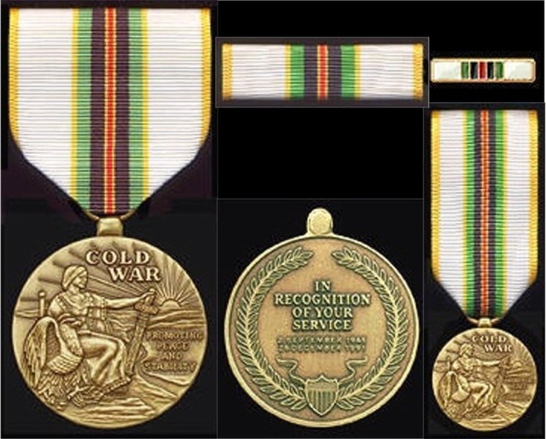  $30.95

Please note that all prices include postage and Handling. You may order by sending a personal check or money order to:
Foxfall Medals
P.O. Box 710
Madison,Virginia 22727
If you have any questions, please feel free to contact us at:

foxfall.medals@gmail.com

