VETERANS
HOW TO OBTAIN YOUR COLD WAR RECOGNITION CERTIFICATE
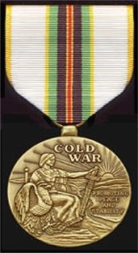
The medal recognizes honorable service between the inclusive dates of September 2, 1945 and December 26, 1991.
This certificate recognizes "members of the Armed Forces and civilian personnel of the Government who served the United States during the Cold War."
All eligible personnel must apply for the certificate on their own behalf. The Department of the Army is the Executive Agent for processing all applications. Send your request by mail to:
CDR, US Army Human Resources Command
Cold War Recognition Program
ATTN: AHRC-PDP-A, Department 480
1600 Spearhead Division Avenue
Fort Knox, KY 40122-5408
If you are no longer on active duty, your best bet is to obtain application procedures directly from the Army and then FAX them a copy of your DD-214 (Certificate of Release/Discharge from Active Duty). Please bear in mind that demand for the certificates has been heavy, and it may take a month or more for your application to be processed.

